26.65: The 20.0- and 30.0- resistors are in parallel and have equivalent resistance 12.0 . The two resistors R are in parallel and have equivalent resistance R/2. The circuit is equivalent to
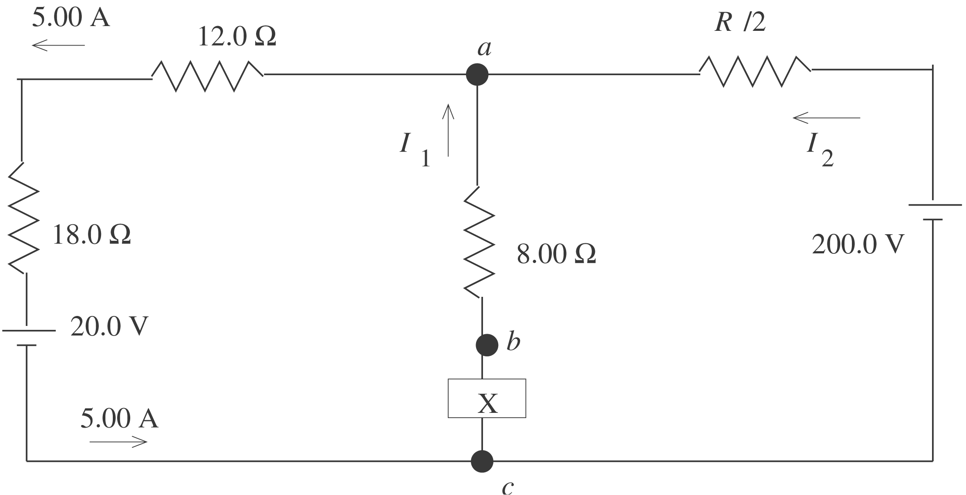

a)
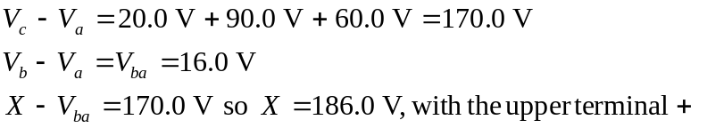

b) 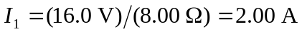
The junction rule applied to point a gives 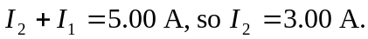 The
current through the 200.0 V battery is in the direction from the terminal, as shown in the diagram.
c) 200.0 V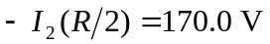
(3.00 A)